**ASP Web API Post Method – From Body**

Create an Api controller called CoursesController. Add a Post method with a parameter called course of type Course and method will add the new course detail to the existing course list.

**Note: Use [FromBody] attribute for course input.**

Create a Model class in models folder as Course.

Create a static list of courses as given in the screenshot. Courses List:

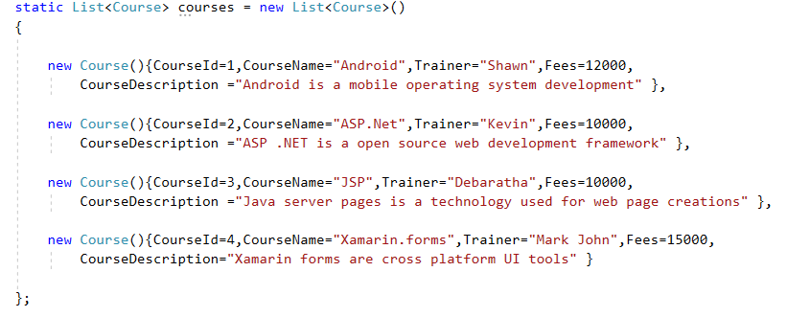

Post method return type should be ‘HttpResponseMessage’. After adding a new course return the newly added course with a ‘HttpStatusCode’ for new object created.

**Output in Postman tool:**

**The Url will be**

<http://localhost:63584/api/Courses> with a POST request in Postman

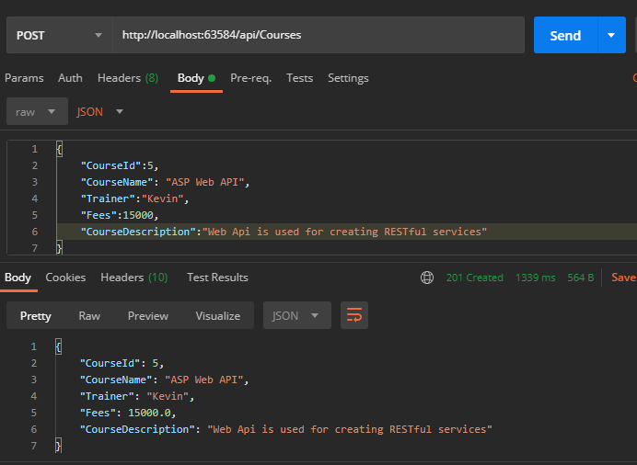

HttpStatusCode

Input Data From Body